Event: Birthday Party
Date: July 2, 2009
Place: Coliseum

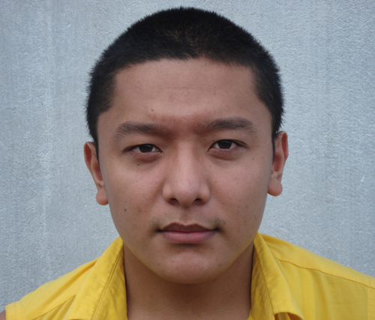

Bring:
- A smile
- Some Candy
- Your meditation mat

